1. **UNDERTIME (In) –** Select **In**, Set the **Undertime Date**, Set the **Time**, Type the **Reason** then click **Submit** button.

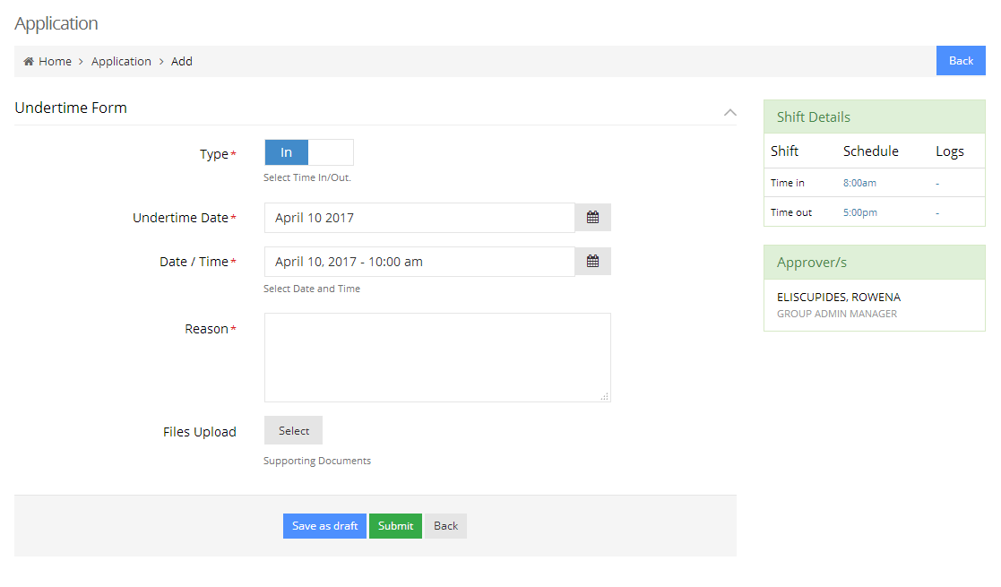



**Date / Time** – Minimum of 2 hours from your work schedule.

1. **UNDERTIME (Out) -** Select **Out**, Set the **Undertime Date**, Set the **Time**, Type the **Reason** then click **Submit** button.

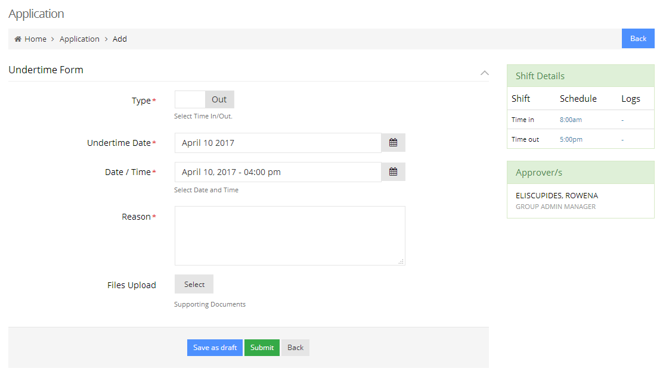



**Date / Time** – Minimum of 1 hour from your work schedule.